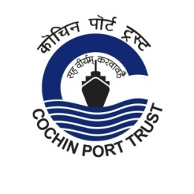
Press Release

Swachhata Pakhwada concluded in Cochin Port

Swachhata Pakhwada was observed in Cochin Port from 16/09/2021 to 30/09/2021 with various programmes including Shramdaan cleaning by employees at their workplaces, office premises, boats / tugs and public spaces in the Port area.
On the valedictory day of Swachhata Pakhwada (30/09/2021) the distribution of Hygiene kits to employees engaged in maintaining general upkeep within the Port area and the two municipal corporation wards in Willingdon Island, was inaugurated by Dr. M. Beena IAS, Chairperson, Cochin Port Trust. Vegetable seed packets were distributed to selected employees of all departments of Cochin Port Trust for developing vegetable gardens at their homes. As an initiative towards popularizing the use of green energy, the solar lights installed at the Embarkation Jetty (public ferry jetty at Northend, Willingdon Island) by Cochin Port Trust were also inaugurated by the Chairperson.
A Cycle Rally to spread the message of Swachhata was held on 28/09/2021 with the participation of sportspersons of Cochin Port Trust and CISF personnel of Cochin Port Trust.
Awareness classes were conducted for the employees of Cochin Port Trust by Medical Department on importance of clean environment and by Marine Department on the importance of keeping water bodies clean. Banners and stickers highlighting the importance of cleanliness were placed on the Ro-Ro vessels, boats and at important locations in the Port area. Short film contest and Poster Designing competition on ‘Swachhata’ theme were conducted for the students of Kendriya Vidyalaya during the Pakhwada period.
Divyaang access facility was constructed at the office of the Wharf Superintendent, Ernakulam Wharf, during the Pakhwada period.
Best maintained offices in each Department of Cochin Port Trust were identified and suitably awarded during the Pakhwada period.
Fifteen truck loads of wastes/garbage were removed from different places in Willingdon Island and dumped at the designated place during the period.
Considering the pandemic situation, the programmes were conducted in compliance of the social distancing and other safety measures in place.
(30/09/2021)
 | cochin_port |  | PortofCochin |  | portofcochin

www.cochinport.gov.in

