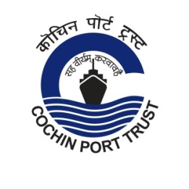
Press Release
Swachhata Pakhwada in Cochin Port Trust

Swachhata Pakhwada 2021 was launched in Cochin Port Trust by administering the Swachhata pledge in all departments. Shramdaan cleaning activities have also been started in the Port areas. Activities proposed during the Pakhwada include cleaning of work places, office premises, crafts and public spaces within the Port area. All Heads of the Department will lead various programmes during the period. Providing ‘divyang’ access to offices, short film competition and poster designing competition for students of Kendriya Vidyalayala Port Trust and several awareness programmes are also planned. All activities are being carried out in compliance of the social distancing/safety instructions issued by the Government to contain Covid-19 pandemic. (16.09.2021)

 | cochin_port |  | PortofCochin |  | portofcochin

www.cochinport.gov.in

