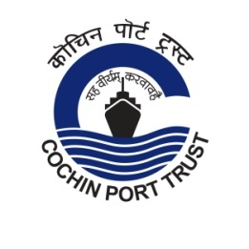
Press Release
Swachhata Pakhwada in Cochin Port Trust
Swachhata Pakhwada 2021 will be observed in Cochin Port from 16th to 30th September 2021. Activities proposed during the Pakhwada include cleaning of work places, office premises, crafts and public spaces within the Port area. All Heads of the Department will lead various programmes during the period. Swachhata Pledge will be administered in all divisions/sections of the Port. Providing ‘divyang’ access to offices, short film competition and poster designing competition for students of Kendriya Vidyalayala, Port Trust and several awareness programme are also planned during the period. All activities will be carried out in compliance of the social distancing/safety instructions issued by the Government to contain Covid-19 pandemic. (15.09.2021)

