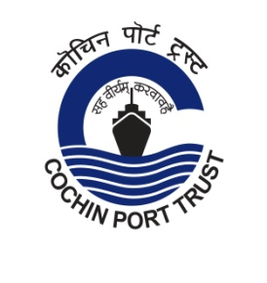
COCHIN FISHERIES HARBOUR
(GOVERNED BY COCHIN PORT TRUST)
Office of the Administrator
Cochin Fisheries Harbour
Thoppumpady
Cochin 682 005
Kerala
Tel:91-0484-2220707/ 0484-2951707
Website: www.cochinport.gov.in

Tender No. AE/T-04/Water ATM/CFH/2021 Date:- 24/08/2021
Tender Extension Notice
Sub: “Tender for Supply and installation of Water ATM of 500 LPH capacity at Cochin
Fisheries Harbour including providing additional AMC of 4 years after the guarantee period”

Ref: This office tender No. AE/T-04/Water ATM/CFH/2021 Date:- 30/07/2021

Please refer to the above. The last date and time of submission of quotation is extended up to 14:30 Hrs on 08.09.2021 and the tender will be opened on 15:00 Hrs on the same day.

All other terms and conditions of the quotation remain unaltered.

Sd/-
Administrator
Cochin Fisheries Harbour
Telefax: 910484 2666639
Phone : 0484-2220707/ 0484-2951707
Email: cfhoffice123

