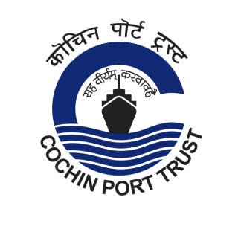
Press Release

'Port Quiz' - for the employees of Cochin Port Trust

'Port Quiz' - the quiz programme for the employees of Cochin Port Trust was conducted today (05/03/2020) at Samudrika Hall, Cochin Port Trust, Willingdon Island.
The programme led by famous quiz master Mr. Snehaj Srinivas and team, was inaugurated by Dr. M. Beena IAS, Chairperson, Cochin Port Trust. The event was supported by M/s Petronet LNG Ltd. Knowledge support for the program was given by Q- factory, Kozhikode.
The preliminary round was attended by 140 employees from 8 departments of the Port. Final session was conducted jointly by Dr. M. Beena IAS and Shri Snehej Srinivas in which 6 teams selected from the prelim-session participated.
The team comprising Shri Joji Paul K and Smt Anjana N bagged the first prize. Shri Biju B.N. and Shri Bright Antony P. Hormis won the second prize and Shri George Prakash James and Shri M.X. Joseph won the third prize.
Dr. M. Beena IAS, Chairperson and Shri Hemant H. Bahura, GM, Petronet LNG distributed certificates to the prize winners.
Heads of Departments of Cochin Port Trust were also present.
(05.03.2020)
