ADDENDUM / CORRIGENDUM NO. 1

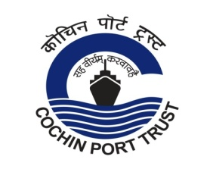 | COCHIN PORT TRUST  An ISO-9001:2015 & ISPS Compliant Port

Phone : 2666414, 2582400 CHIEF ENGINEER’S OFFICE,
Telefax : 91 0484 2666414 COCHIN – 682 009.
Email :ce@cochinport.gov.in, coptce@gmail.com
Website: www.cochinport.gov.in

No.T15/T-1941/ 2021-C Dated: 29-03-2021

TENDER FOR ENGAGING A THIRD PARTY CERTIFICATION CUM SURVEY AGENCY FOR MONITORING THE MAINTENANCE DREDGING FOR THE YEAR 2021-22 AT COCHIN PORT

(Tender No. No.T15/T-1941/ 2021-C)

Please note the following:

Sl. No | Item details | Existing | To be read as
1 | Last Date and Time of submission of Bids | 14.30 hours on 05-04-2021 | 14.30 hours on 12-04-2021
2 | Date and Time of opening the Bids | 15.00 hours on 05-04-2021 | 15.00 hours on 12-04-2021

All other terms & conditions of tender remain unchanged

Sd/- CHIEF ENGINEER

